Maria’s Week

On weekdays, I 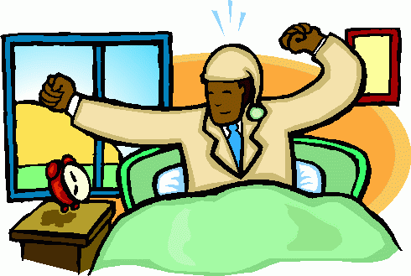 at half past seven. I, 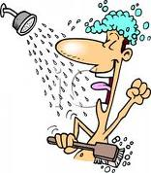,  my hair and 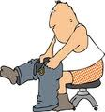. I go to school by 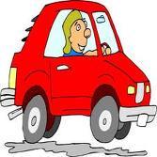. School starts at 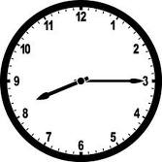. Break is from 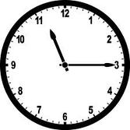to quarter to twelve. 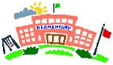 finishes at half past two. I have 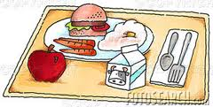 at three o'clock

On weekdays, I get up at half past seven. I have a shower, brush my hair and get dressed. I go to school by car. School starts at a quarter past eight. Break is from quarter past eleven to quarter to twelve. School finishes at half past two. I have lunch at three o'clock.

